TCP and UDP are transaction protocol widely used in everyday life from e-mail, FTP, streaming media, TFTP, games and etc. However each of the transaction protocol have their advantages and disadvantages, following test was performed to determine the reliability of each transaction protocol (TCP and UDP). In a sense UDP is a connectionless protocol, which means that that there is no transaction of the message being sent or even if the message was received. Whereas TCP is a connection oriented protocol, where messages are sent and are always delivered to the destination unless connection goes down. The speed between UDP and TCP very a lot as UDP is much quicker than TCP, but UDP may not send all the messages to the server. To test this out I created a programs that would test the reliability of TCP and UDP based on how many packets are received compared to dropped packets. The program was used to send total of 10000 messages at 1000 bytes per message there were no dropping of packets over TCP communication (all packets were received by the TCP Server) as seen in **Figure 1**. However, for UDP with the same condition of 10000 messages at 1000 bytes per message about 6320 datagrams packets were dropped as seen in ***Figure 2***. This is about 63.2% of dropped packets over UDP connection, this shows that UDP is not that reliable and that TCP is more reliable. Note: These test were performed with the same conditions.

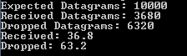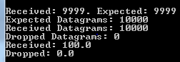

Figure 2 Results from UDP run

Figure Results from TCP run